Barbwire
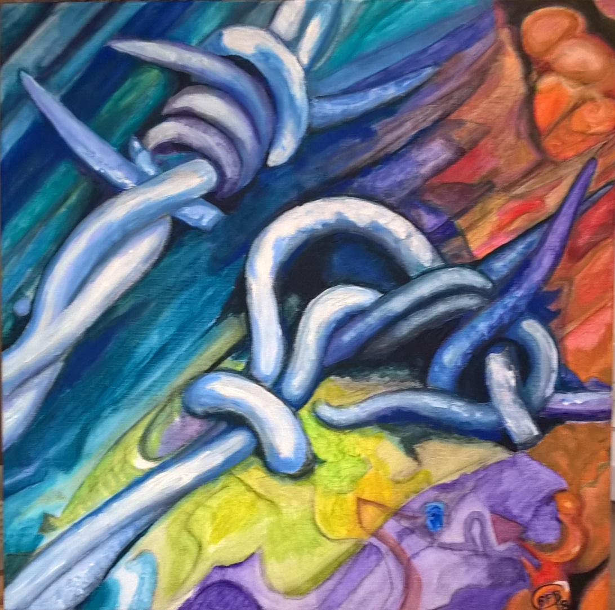
This is one of my Bridgwater Circle series of paintings belonging to the Bolt & fixings set. The image was captured near the canal bridge at old Taunton Road Bridgwater Somerset. I grew up with barbed wire on the farm in Dorset so a very familiar sight to me but not quite so commonplace in the town of Bridgwater Somerset.
I really enjoyed painting this in its carnival colours. I realise that often barbed wire is used in bad situations including war and imprisonment, designed to be dangerous so its normal connotations are often dark in nature but here it is doing a fine job keeping up an old fence embedded in the wood which is time worn, greyed, softened and lined with age just a beautiful memory of my childhood.
Bridget Penn-Berkeley December 2018 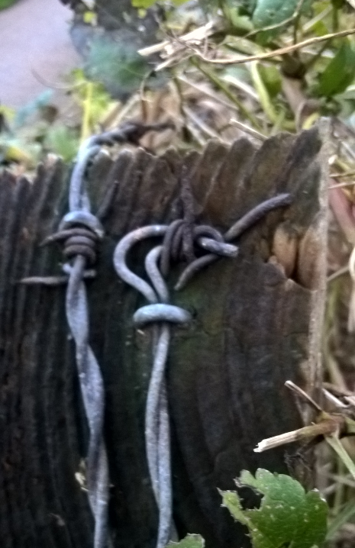 Original photograph

